
2010 Baptisms

From left to right (front):
Caleb Fisher,
Katie Jackson,
D’kauri Jordan.
(Middle & Back): Raye Beasley,
David Fisher,
Jerry Cook,
Travis & Misty Stecher,
Rena Miller,
Wendy & Randy Schauer.

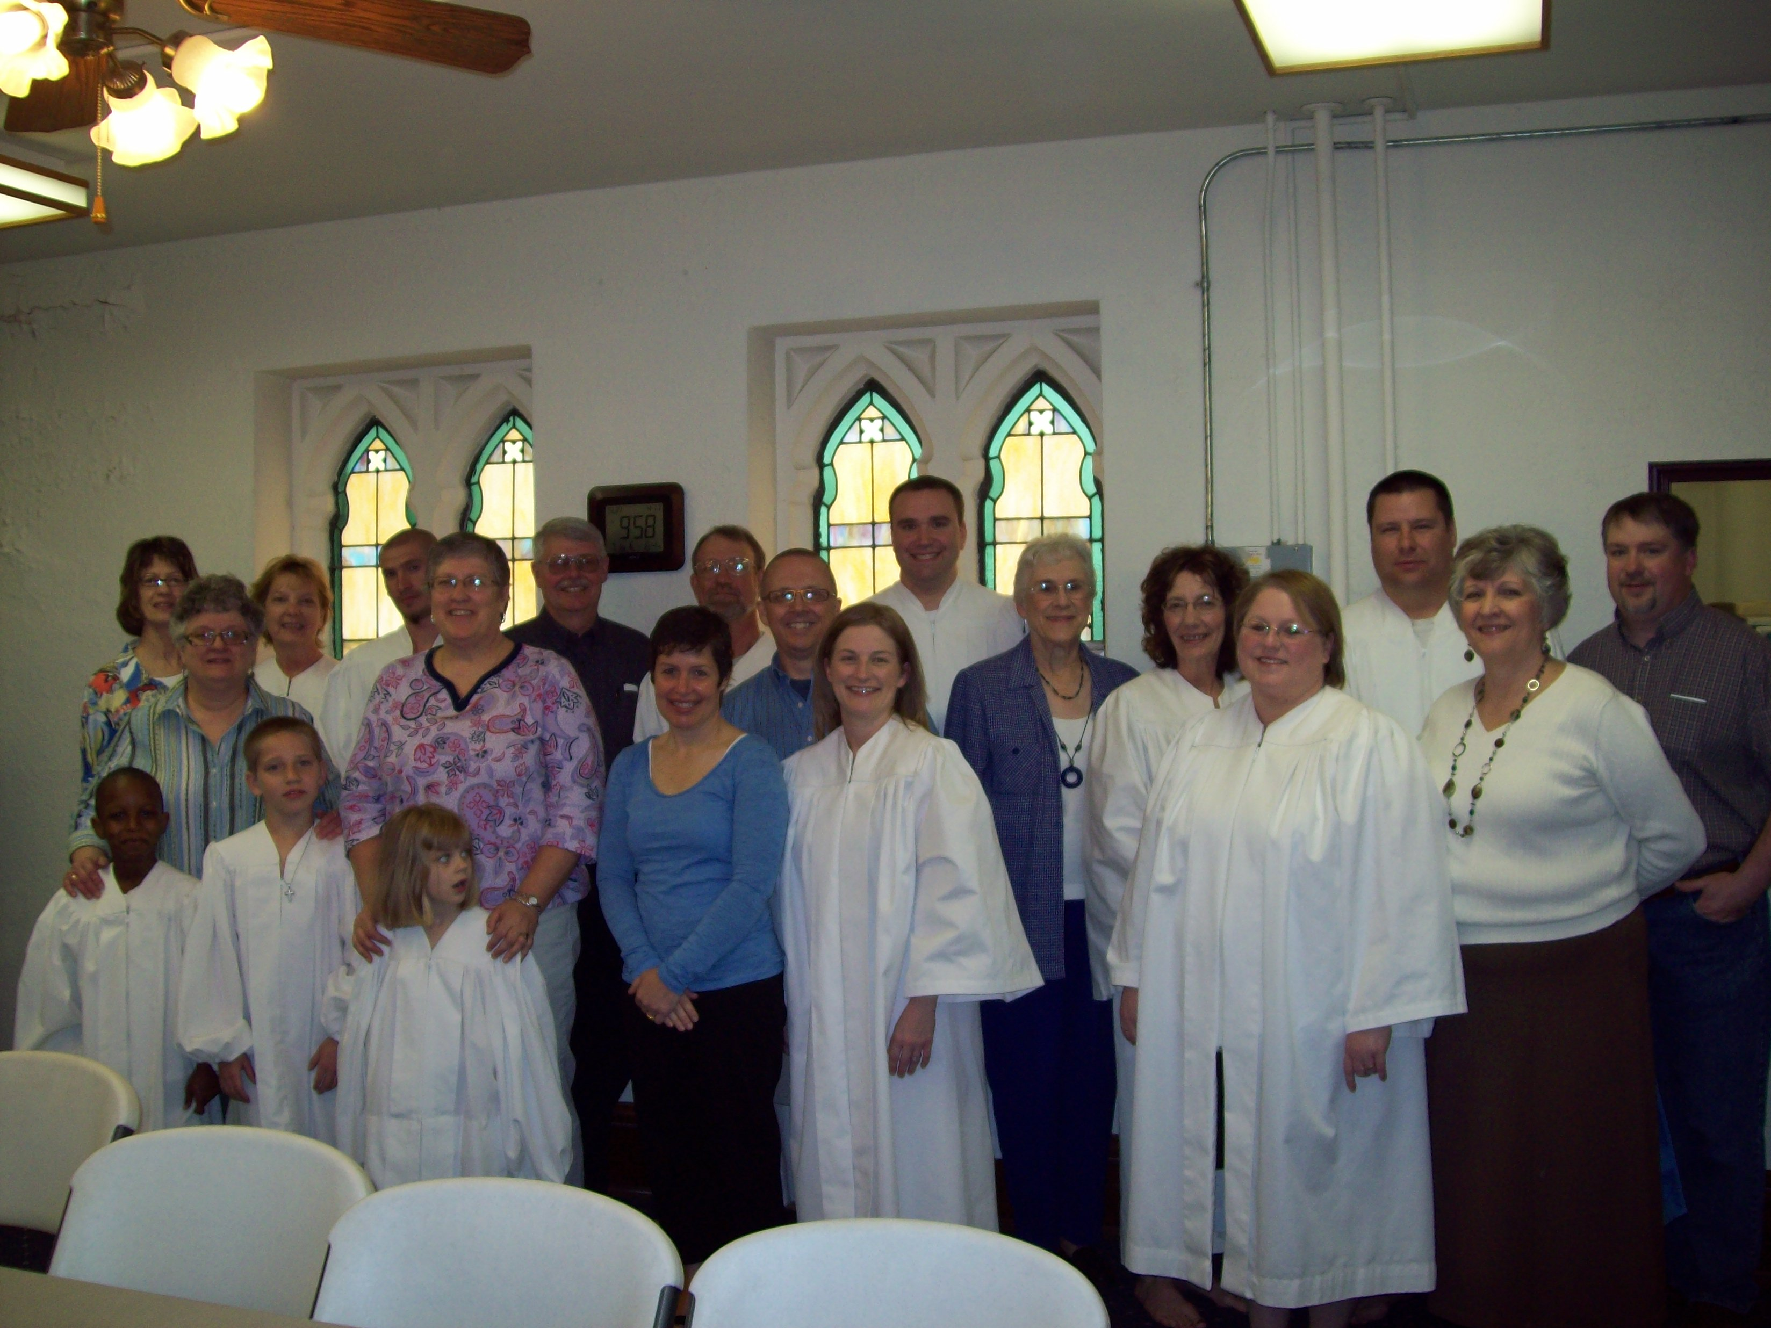

Sponsors

Brenda Fell,
Candi Moulton,
Steph Line,
Laurie Aten,
Jeff Anderson,
Sue Johnson,
Jan Luallen,
Todd VanVelsor.



Drake Ziegler
Confession of Faith on April 11, 2010

